**Name-Tasmiya Fathima**

**USN-1BM19CS172**

**PROGRAM 4-(Student Faculty Database)**

Consider the following database for student enrollment for course :

STUDENT(snum: integer, sname:string, major: string, lvl: string, age: integer)

CLASS(cname: string, meetsat: time, room: string, fid: integer)

ENROLLED(snum: integer, cname:string)

FACULTY(fid: integer, fname:string, deptid: integer)

create database Lab4;

use Lab4;

create table student(snum int, sname varchar(10), major varchar(2), lvl varchar(2), age int,primary key (snum));

desc student;

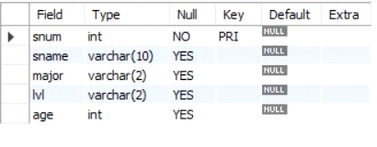

create table faculty(fid int, fname varchar(20), deptid int,primary key(fid));

desc faculty;

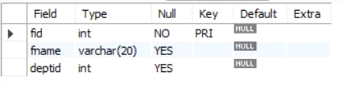

create table class(cname varchar(20), meetsat timestamp, room varchar(10), fid int,primary key (cname),foreign key(fid) references faculty(fid));

desc class;

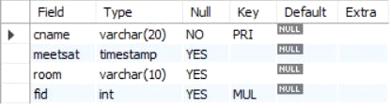

create table enrolled(snum int, cname varchar(20),primary key(snum,cname),

foreign key(snum) references student(snum),

foreign key(cname) references class(cname));

desc enrolled;

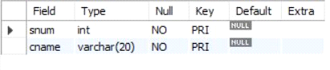

insert into student values(1, 'jhon', 'CS', 'Sr', 19);

insert into student values(2, 'Smith', 'CS', 'Jr', 20);

insert into student values(3 , 'Jacob', 'CV', 'Sr', 20);

insert into student values(4, 'Tom ', 'CS', 'Jr', 20);

insert into student values(5, 'Rahul', 'CS', 'Jr', 20);

insert into student values(6, 'Rita', 'CS', 'Sr', 21);

select * from student;

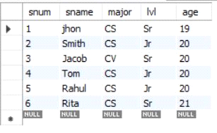

insert into faculty values(11, 'Harish', 1000);

insert into faculty values(12, 'MV', 1000);

insert into faculty values(13 , 'Mira', 1001);

insert into faculty values(14, 'Shiva', 1002);

insert into faculty values(15, 'Nupur', 1000);

select * from faculty;

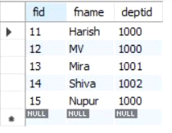

insert into class values('class1', '12/11/15 10:15:16', 'R1', 14);

insert into class values('class10', '12/11/15 10:15:16', 'R128', 14);

insert into class values('class2', '12/11/15 10:15:20', 'R2', 12);

insert into class values('class3', '12/11/15 10:15:25', 'R3', 12);

insert into class values('class4', '12/11/15 20:15:20', 'R4', 14);

insert into class values('class5', '12/11/15 20:15:20', 'R3', 15);

insert into class values('class6', '12/11/15 13:20:20', 'R2', 14);

insert into class values('class7', '12/11/15 10:10:10', 'R3', 14);

select * from class;

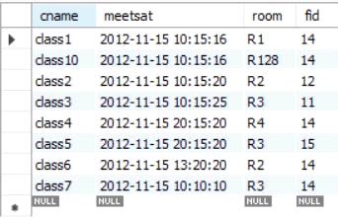

insert into enrolled values(1, 'class1');

insert into enrolled values(2, 'class1');

insert into enrolled values(3, 'class3');

insert into enrolled values(4, 'class3');

insert into enrolled values(5, 'class4');

insert into enrolled values(1, 'class5');

insert into enrolled values(2, 'class5');

insert into enrolled values(3, 'class5');

insert into enrolled values(4, 'class5');

insert into enrolled values(5, 'class5');

select * from enrolled;

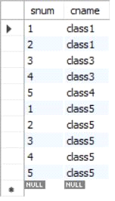

**i. Find the names of all Juniors (level = JR) who are enrolled in a class taught by Harish**

SELECT DISTINCT S.sname

FROM student S, class C, enrolled E, faculty F

WHERE S.snum = E.snum AND E.cname = C.cname AND C.fid = F.fid AND

F.fname = 'Harish' AND S.lvl = 'Jr';



**ii.Find the names of all classes that either meet in room R128 or have five or more Students enrolled.**

SELECT C.cname

FROM class C WHERE C.room = 'R128'

OR C.cname IN (SELECT E.cname FROM enrolled E

GROUP BY E.cname HAVING COUNT(*) >= 5);

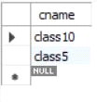

**iii. Find the names of all students who are enrolled in two classes that meet at the same time.**

SELECT DISTINCT S.sname

FROM student S

WHERE S.snum IN (SELECT E1.snum

FROM enrolled E1, enrolled E2, class C1, class C2

WHERE E1.snum = E2.snum AND E1.cname <> E2.cname

AND E1.cname = C1.cname

AND E2.cname = C2.cname AND C1.meetsat = C2.meetsat);

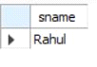

**iv.Find the names of faculty members who teach in every room in which some class is taught.**

SELECT f.fname,f.fid

FROM faculty f

WHERE f.fid in ( SELECT fid FROM class

GROUP BY fid HAVING COUNT(*)=(SELECT COUNT(DISTINCT room) FROM class) );

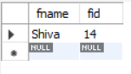

**v.Find the names of faculty members for whom the combined enrollment of the courses that they teach is less than five.**

SELECT DISTINCT F.fname

FROM faculty F

WHERE 5 > (SELECT COUNT(E.snum)

FROM class C, enrolled E

WHERE C.cname = E.cname

AND C.fid = F.fid);

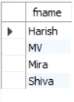

**vi. Find the names of students who are not enrolled in any class.**

SELECT DISTINCT S.sname

FROM student S

WHERE S.snum NOT IN (SELECT E.snum

FROM enrolled E );



**vii.For each age value that appears in Students, find the level value that appears most** **often.**

SELECT S.age, S.lvl

FROM Student S

GROUP BY S.age, S.lvl

HAVING S.lvl IN (SELECT S1.lvl FROM Student S1

WHERE S1.age = S.age

GROUP BY S1.lvl, S1.age

HAVING COUNT(*) >= ALL (SELECT COUNT(*)

FROM Student S2

WHERE s1.age = S2.age

GROUP BY S2.lvl, S2.age));

